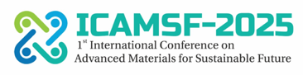

1st International Conference on Advanced Materials for Sustainable Future (ICAMSF-2025)
Theme: Energy, Efficiency and Economy for Sustainability
28th-29th March 2025

SPONSORSHIP FORM
We are interested in participating and sponsoring the 1st International Conference on Advanced Materials for Sustainable Future (ICAMSF-2025), held from 28th to 29th March 2025 in Chitkara University Rajpura, Punjab, India. (Kindly Tick the Category of Sponsorship)

- Silver
- Gold
- Platinum
- Diamond
- Powered
- Others

Name of Person:

Organization/Institution:

Address:

Telephone/Mobile Number:

Email:

*Kindly send this filled form to Dr. Jitendra Kumar Katiyar, Conference Chair, ICAMSF-2025, in their email: icamsf@chitkara.edu.in.

Signature and Seal of Authority

