ACTIVITY REPORT

Name of the activity | Career Counselling Program in Collaboration with ICSI | Date | 11th Sep, 23
Name of the Moderator | Dr. Deepak Sood | Time | 2:00 pm -4:00 pm
Name of the Resource Person | CS Ankur Gauba, Chairman ICSI  CS Sumit Bhojwani, Vice Chairman, ICSI | Mode | Offline
Nature of the activity | Value Added Course | Program & Batch | BBA Professional (All batches)
Number of students participated | 500 | Academic Session | 2023-2024

About the Activity

A career counselling program in collaboration with The Institute of Company Secretaries of India (ICSI) was organized by BBA Professional, Chitkara Business School, Chitkara University, Punjab, India for UG students. The eminent resource person for the program were CS Ankur Gauba, Chairman, Ludhiana chapter ICSI and CS Sumit Bhojwani, Vice chairman, Ludhiana Chapter of NIRC. This career counselling program aims to provide valuable insights into the field of Company Secretaries. CS Sumit Bhojwani wonderfully elaborated the various aspects associated with ICSI in terms of roles, responsibilities and power of a company secretary. CS Sumit Bhojwani also discussed about the “Journey of how to became a CS”. He also emphasized on the demand of CS in job market, CS is one of the most demanded jobs internationally along with the relevant and crucial points while answering wonderfully to the queries raised by the audience. The latest trends in the field of company secretary were duly discussed in the session which helps students to identify new opportunities in the field. The opportunities and challenges in the field of company secretary will certainly help students to take rational decisions which will benefit them in their future endeavors. This program was specifically designed to assist our students making informed decisions about your career paths.

Aligned Activity Outcomes with Objectives

Activity Objectives | Activity Outcomes
1. To Provide students with valuable insights and knowledge in a specific field. | 1.After attending the lecture, students exhibit a deeper understanding of the subject matter and an increased ability to apply relevant concepts in their coursework and beyond.
2. To Offer guidance and inspiration for students' future career paths. | 2.Students gain clarity about their career goals and are better equipped to make informed decisions about pursuing a profession in the field discussed during the lecture.
3 To Facilitate connections and interactions between students and industry experts. | 3.Attendees establish valuable connections with guest speakers and peers, potentially leading to internship opportunities, mentorship, or collaborative projects.

GLIMPSES OF THE ACTIVITY

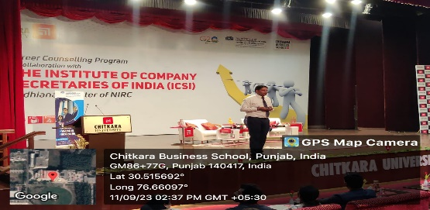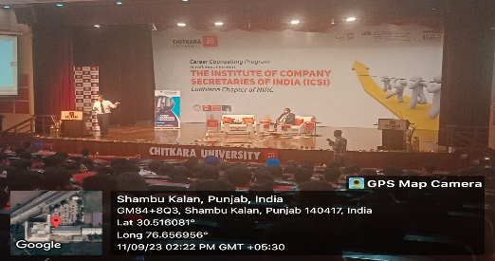

“Resource Persons sharing valuable insights with students”

