
__________________________________________________________________________________

YOUNG LEADERS SUMMIT ON SUSTAINABLE LEADERSHIP-2023
1 | Type of Activity | Leadership Summit (Expert Talks and Competitions on Leadership)
2 | EVENT THEME (KEYWORDS) | Empowering Tomorrow's Trailblazers: Nurturing Leadership in Youth  This theme aims to provide a comprehensive understanding of Leadership skills and need connecting with Industry 4.0. Three competitions were also included based on the event theme.
3 | Duration of the Event | 2 Days
4 | Dates of the Event | 14th Dec 2023 to 15th Dec 2023
5 | Description of an Event
5 | The Second Young Leaders Summit on Sustainable Leadership-2023, organized by students from Chitkara University, Punjab, who are part of the Integrated Programme in Management (IPM) & Liberal Arts, took place on December 14th and 15th, 2023. The summit's theme, "Empowering Tomorrow's Trailblazers-Nurturing Leadership in Youth," set the stage for discussions and activities.  Esteemed speakers, Mr. D. V. Shastry, Executive Director of the Natural Gas Society (NGS), and Dr. Harsh Sachdev, Former Executive Director of the Indian Oil Corporation Limited (IOCL), delivered expert talks. Mr. Shastry highlighted practical aspects of leadership, drawing from his experiences to instill self-belief among the students. Dr. Sachdev engaged in discussions about rational management approaches and sustainability mechanisms, sharing insights from his experiences, encouraging a realistic understanding among the students.  The participation of IPM & Liberal Arts students was remarkable in various events such as AdMad - Ideation Fusion, Poster Exhibition, and Best Out of Waste, showcasing their active involvement and enthusiasm.
6 | Mention number of students (Event): 150
7 | Mention number faculty (Event): 4
8 | Objective of the event in 3 words: Learning, Creativity and Empowerment.
9 | Benefit of the activity: Learning from the experts, Better Leadership.
10 | Photographs
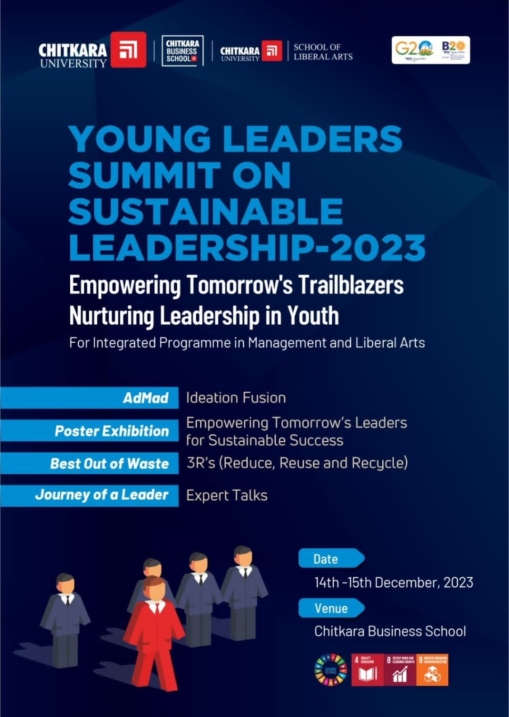 |  |  | 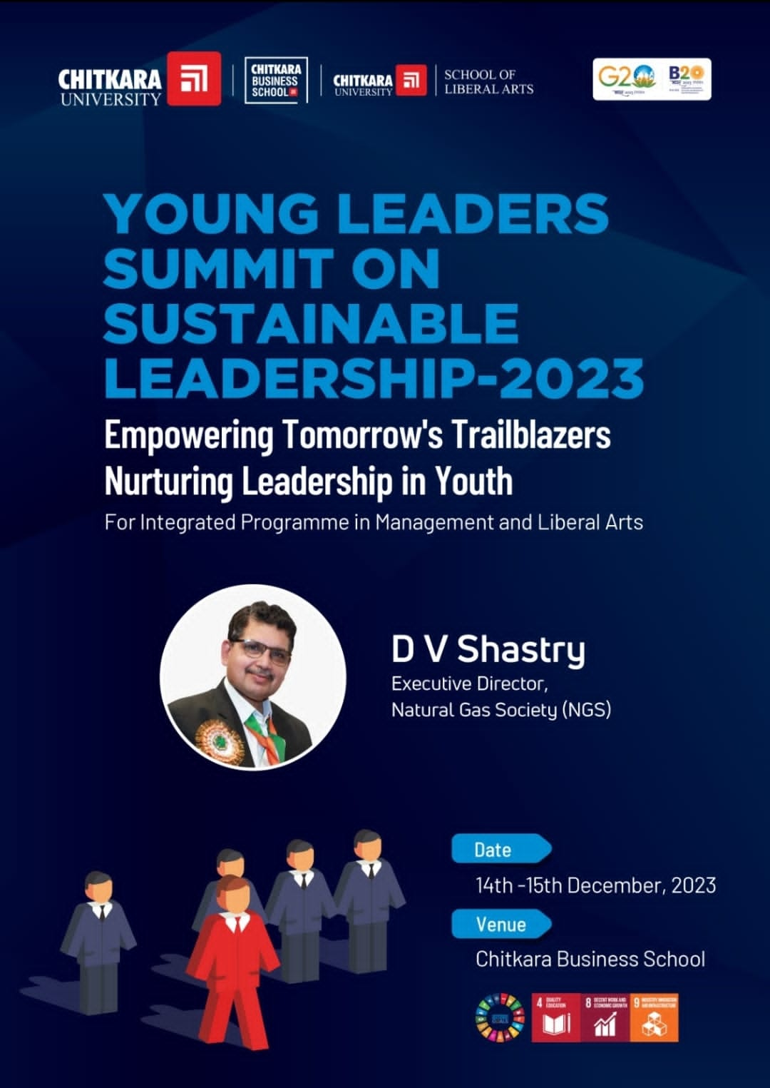
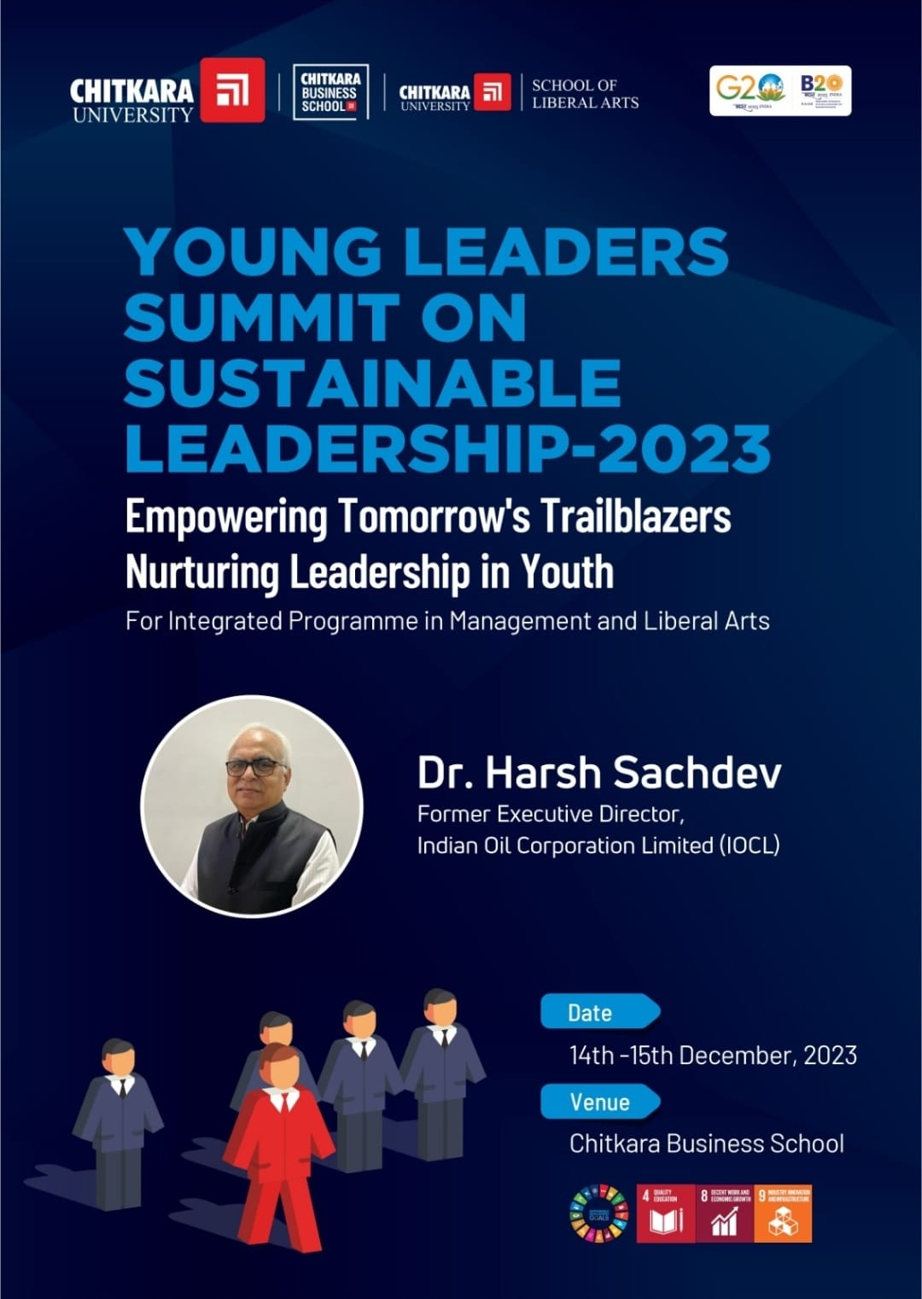 |  |  | 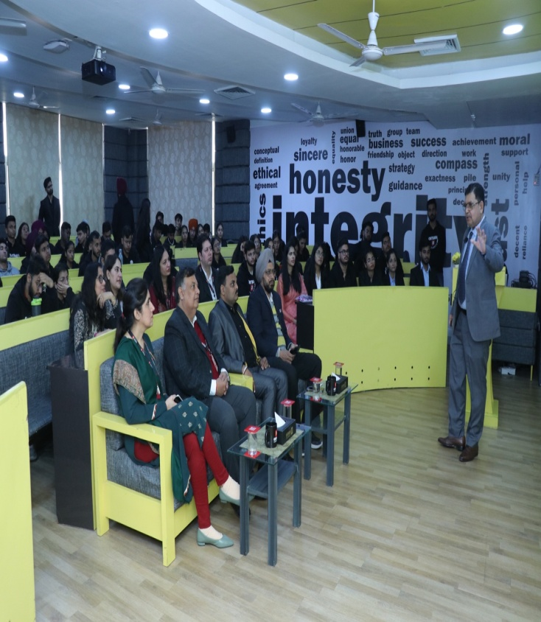
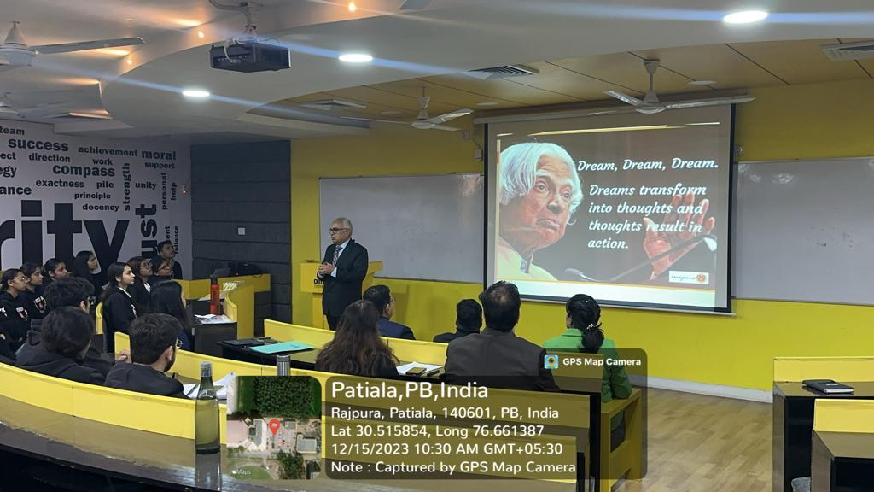 |  |  | 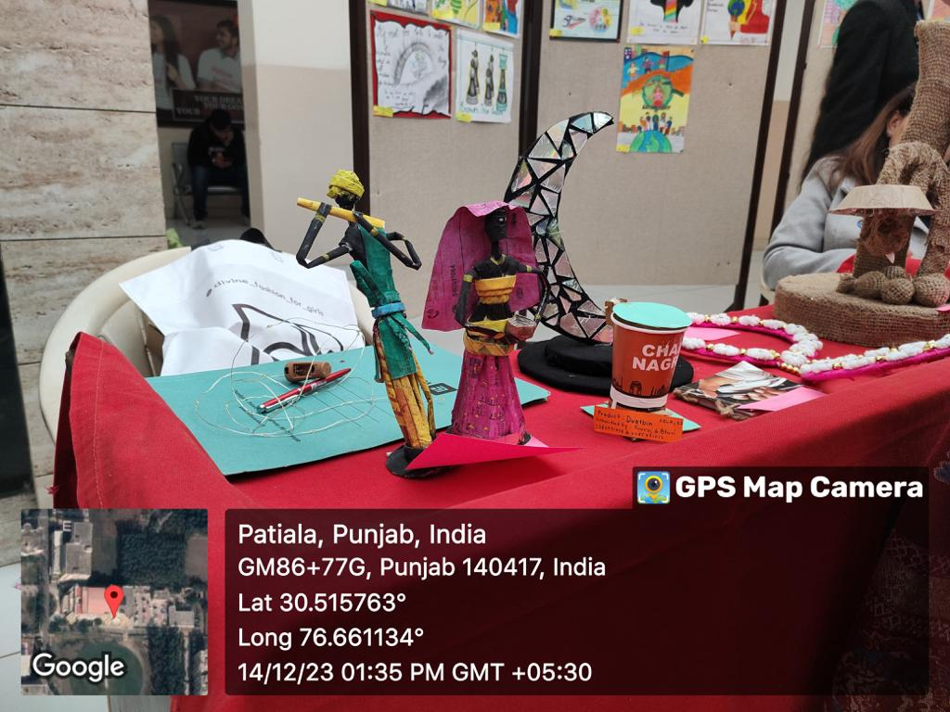
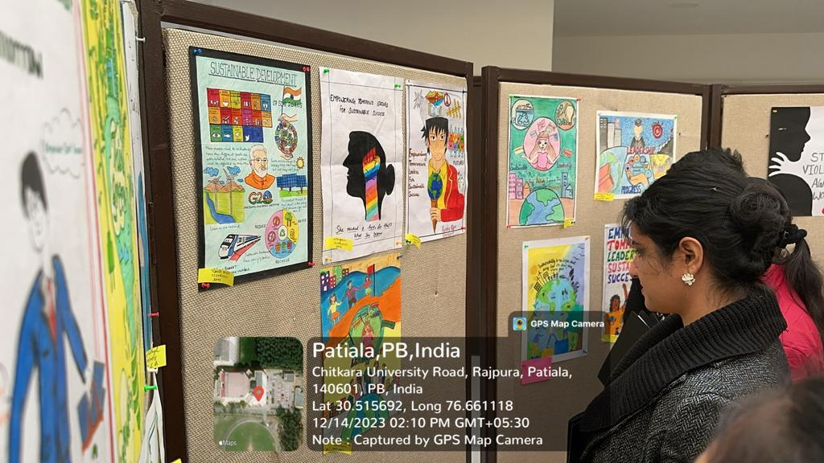 |  |  | 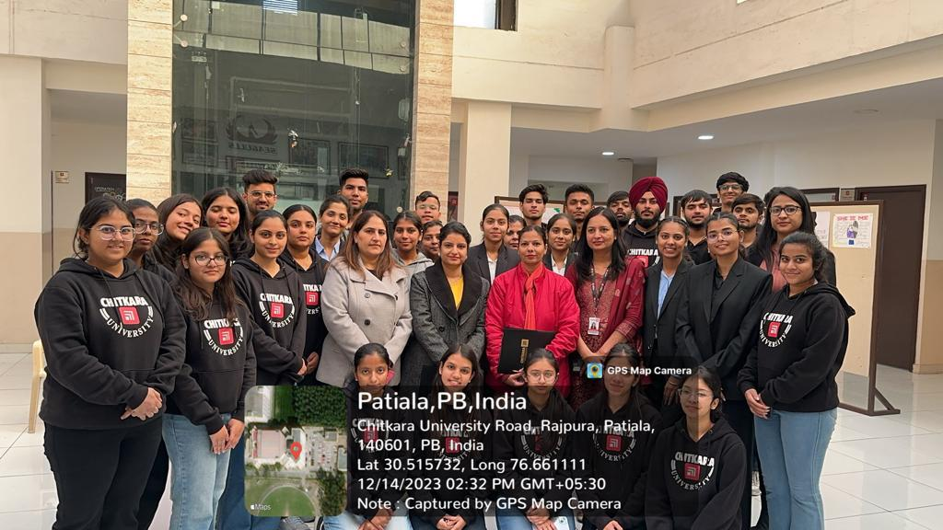
Name of Department: |  |  | Chitkara Business School and Chitkara School of Liberal Arts
Organiser: |  |  | Integrated Programme in Management Team
Resource Person Details:
Name: D V Shastry |  |  | Name: Dr. Harsh Sachdev
Designation: Executive Director |  |  | Designation: Former Executive Director
Organization: National Gas Society (NGS) |  |  | Organization: Indian Oil Corporation Limited (IOCL)
Competition activities: |  |  | - Ideation Fusion  - Poster Making  - Best out of waste

