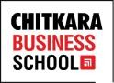
ACTIVITY REPORT

Name of the activity | Career Counselling Session | Date | 24th August., 2023
Name of the Moderator | Col. Bikram Ahluwalia | Time | 9:30am onwards
Name of the Resource  Person | Aanchal Chopra | Mode | Offline
Nature of the activity | Career Counselling Session | Program & Batch | MBA(HR) Batch 2023
Number of students participated | 60 | Academic  Session | Jan- June, 2023

About the Activity
Aanchal Chopra, Regional Head and Account Director at A & G, delivered an insightful career counseling session focused on the invaluable benefits of LinkedIn for management students. With her extensive industry experience, she shed light on how this professional networking platform can be a game-changer in the realm of career development. Ms. Chopra emphasized how LinkedIn serves as an indispensable tool for students pursuing management degrees, offering them a platform to connect with industry professionals, gain exposure to cutting-edge trends, and build a strong professional network. Her session illuminated the vast potential LinkedIn holds in aiding students to discover job opportunities, access valuable resources, and ultimately embark on successful career journeys in the field of management.

Aligned Activity Outcomes with Objective
Activity Objectives | Activity Outcomes
- To help management students understand the full potential of LinkedIn as a career development tool. | Students gained a deeper understanding of LinkedIn's features and how to optimize their profiles.
- To empower students with the skills and knowledge needed to build a strong professional network. | Students learned how to expand their professional networks.
- To make students aware of the importance of staying updated with industry trends. | Students left the session with the ability to follow industry leaders and join relevant groups and discussions on Linked in. & stay informed about current trends and engage in meaningful conversations within their field.
- To equip students with the ability to leverage LinkedIn for job hunting and accessing valuable resources such as articles, webinars, and online courses related to management. | Students learned about how to navigate the job market and make informed career decisions.
GLIMPSES OF THE ACTIVITY
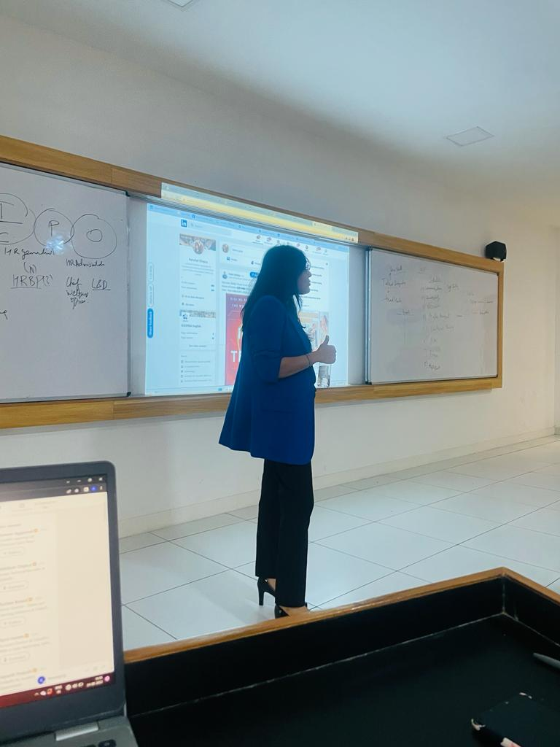
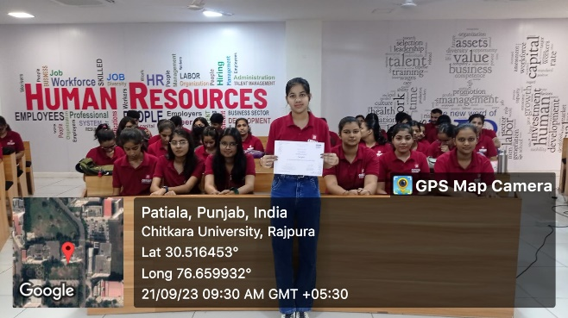

“MBA (HR) Department conducting an activity for students.” “Student with the certificate, after the session.”

