ACTIVITY REPORT

Name of the activity | Career Counselling Session | Date | 19th August., 2023
Name of the Moderator | Col. Bikram Ahluwalia | Time | 9:30am onwards
Name of the Resource  Person | Mr. Sukhwinder Singh, Senior Manager, Naukri.com | Mode | Offline
Nature of the activity | Career Counselling Session | Program & Batch | MBA HR 2023 Batch
Number of students  participated | 60 | Academic  Session | Jan- June, 2023

About the Activity
During the career counseling session, Mr. Sukhwinder Singh, Senior Manager at Naukri.com, provided valuable insights into how Naukri.com is a game-changer for management students and aspiring professionals. He emphasized that Naukri.com offers a comprehensive platform where management students can not only search for relevant job opportunities but also access a plethora of resources to enhance their career prospects. Mr.Sukhwinder highlighted the benefits of the portal, including personalized job recommendations, skill development courses, and resume-building tools, all tailored to meet the unique needs of management students. This informative session left our students inspired and well-equipped to harness the full potential of Naukri.com for their career advancement.

Aligned Activity Outcomes with Objective
Activity Objectives | Activity Outcomes
- To introduce management students to the features and benefits of Naukri.com as a career resource | Students gained a deeper understanding of Naukri.com that helps them in job searches and skill development.
- To empower students with the knowledge of how to effectively use Naukri.com's tools for skill development and resume-building, enabling them to present themselves as strong candidates in the job market. | Students learned how to expand their professional networks enhanced their resumes and online profiles on Naukri.com, making them more attractive to potential employers.
- To encourage students to actively engage with the Naukri.com community by participating in forums and discussions, thereby expanding their professional networks and gaining access to valuable industry insights. | Students' active participation in Naukri.com forums and discussions, indicating their engagement with the platform's networking and knowledge-sharing opportunities.
- To inspire and motivate students to proactively utilize Naukri.com as a resource for career advancement, ensuring they feel well-prepared and confident in their job search and career development efforts. | Increased motivation and confidence of students in their job search and career development efforts

GLIMPSES OF THE ACTIVITY

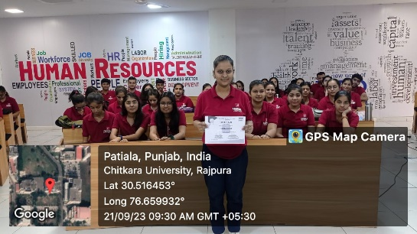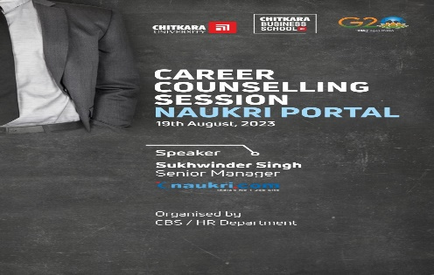
“Student with the certificate, after the session.” “Flyer of the session”

