LIST OF CANDIDATES TRAINED IN HOSPITALITY COURSES UNDER HSRT SCHEME OF MINISTRY OF TOURISM, GOVT. OF INDIA DURING THE YEAR 2014-15
Course: Food Production (Cookery) Batch No. 1 (13th Oct to 15th Dec 2014) Year: 2014-15
S. No. | Name of Trainee | Photo | DOB | Qualification | Residential Address | Contact Detail | Institute / Organization where placed | Salary per month  (Rs)
 | Amandeep Singh | 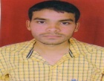 | 2-Feb-92 | 10+2 | V.P.O Mandouli, Tehsil- Rajpura, Distt Patiala | 98883-05049 | - | -
 | Lovely | 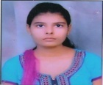 | 8-Apr-92 | 10+2 | Plot No. 16 Near 3095 Opp City Thana, Rajpura, Distt Patiala | 96465-55850 | - | -
 | Kiran | 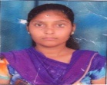 | 18-Jan-92 | 10+2 | # TYB- 3 Near D.R.M Office Rail Vihar, Ambala Cantt | 90341-85587 | McDonald’s Rajpura | Offer letter Issued
 | Kulvinder Kaur | 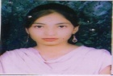 | 11-May-95 | 10+2 | Guru Amardass Colony, Choona Bhadhi, Rajpura Town, Distt Patiala | 78371-96566 | - | -
 | Mandeep Singh | 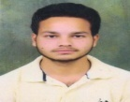 | 11-Jun-94 | 10+2 | # 170, Arjan Dev Colony, Rajpura | 96466-18180 | - | -
 | Shivani | 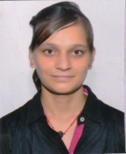 | 7-Aug-92 | B.A | # 1409 Near Mahavir Mandir Rajpura Distt Patiala | 99883-86269 | Scholar Senior Secondary School, Rajpura | 8000
 | Balwinder Kumar | 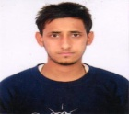 | 6-Aug-95 | 10+2 | # 96 Ward No. 5, Amir Colony, Rajpura Patiala | 80545-40754 | - | -
 | Davinder Kaur | 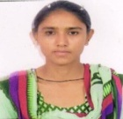 | 12-Apr-93 | 10+2 | Vill Pehar Khurd Tehsil Rajpura Distt Patiala | 81959-99881 | Mc Donald’s Rajpura | Offer letter Issued
 | Gurwinder Kaur | 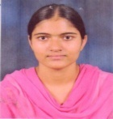 | 5-Mar-94 | 10+2 | Vill Pehar Khurd,Tehsil Rajpura, Distt Patiala | 99153-41681 | McDonald’s Rajpura | Offer letter Issued
 | Karamjeet Kaur | 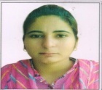 | 20-Feb-91 | 10+2 | Ekta Colony, Rajpura Chd Road | 98883-43649 | - | -
 | Parveen Kumar | 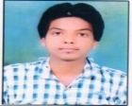 | 28-Nov-94 | 8th | Bathonia P.O Sorho Tehsil Rajpura Distt Patiala | 82890-63728 | Chitkara Hostel Mess | 5000/-
 | Rajni Sharma | 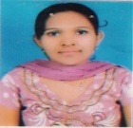 | 26-Dec-93 | 10+2 | H- 75 P&T Colony, Near Railway Hospital, Ambala Cantt | 94169-95330 | McDonald’s Rajpura | Offer letter Issued
 | Gurjeet Singh | 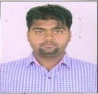 | 28-Jul-95 | 10th | # 37 Valimiki Colony , Near Partap Colony Rajpura Town | 96464-84949 | McDonald’s Rajpura | Offer letter Issued
 | Tanish Kumar |  | 17-Aug-91 | 10th | Vill & P.O Pabri, Tehsil Rajpura, Distt Patiala | 94642-52310 | Govt. Senior Secondary School, Pabri (Rajpura) | 6000/-
 | Komal Rani | 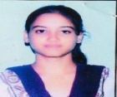 | 25-Jan-94 | 10th | # 107 Vill Kalomajra, Tehsil Rajpura Distt Patiala | 94175-33001 | - | -
 | Kush Batra | 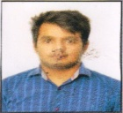 | 12-Feb-95 | 10th | # 76, Guru Arjan Dev Colony, Rajpura Town | 99881-23476 | - | -
 | Lovely Rani | 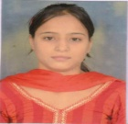 | 31-Jul-94 | 10+2 | # 2800 Near Durga Mandir Road Rajpura Town | 98555-64979 | - | -
 | Gaurav Sharma | 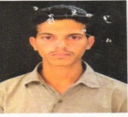 | 2-Mar-93 | 10+2 | V.P.O Thuha Tehsil Rajpura Distt Patiala | 97818-66486 | Chitkara University Cafeteria | 5000/
 | Sarbjeet Kaur |  | 2-Jun-86 | 10+2 | # 9, Guru Amardas Colony, Behind New Grain Market, Rajpura Town | 94650-23938 | - | -
 | Gaurav Gupta | 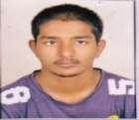 | 27-Dec-94 | 10th | V.P.O Thuha Tehsil Rajpura Distt Patiala | 97818-96686 | - | -
 | Amandeep Singh |  | 21-Jan-94 | 10+2 | V.P.O Jhansla, Tehsil Rajpura Distt Patiala | 78371-77490 | - | -
 | Avtar Singh | 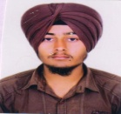 | 17-Feb-94 | 10+2 | V.P.O Thuha Tehsil Rajpura Distt Patiala | 99146-13919 | Chitkara University Cafeteria | 5000/
 | Ajay Kumar | 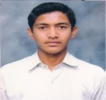 | 12-Aug-95 | 10th | V.P.O Jhansla, Tehsil Rajpura Distt Patiala | 88726-11376 | - | -
 | Karamjeet Kaur | 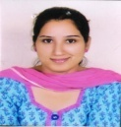 | 20-May-88 | B.A | # 89, Guru Nanak Colony, Rajpura Distt Patiala | 98780-10922 | - | -
 | Navy Virk | 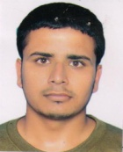 | 22-Feb-93 | 10+2 | Vill Bibipur, Jakhepal, Tehsil Rajpura, Distt Patiala | 81460-21004 | - | -
 | Amritpal Singh | 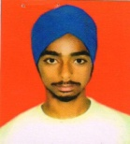 | 5-Oct-94 | 10th | Vill. Sainian, P.O Basant Pura, Tehsil Rajpura Distt Patiala | 97800-47457 | - | -
 | Sandeep Kaur | 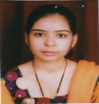 | 4-Apr-89 | B.A | Vill. Bhoglan,P.O Suhron, Tehsil Rajpura,Distt Patiala | 99143-22459 | McDonald’s Rajpura | Offer letter Issued
 | Sharang Dhar Salwan | 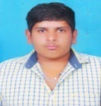 | 2-Sep-95 | 10th | # 1245 Arrorian Wala Mohalla Old Rajpura Distt Patiala | 97801-99780 | - | -
 | Reena | 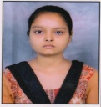 | 20-Mar-95 | 10th | # 2800 Near Durga Mandir Road Rajpura Town | 98884-65490 | - | -
 | Vinod Kumar | 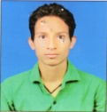 | 12-Sep-95 | 10th | Vill. Agarmanral, PO PO Khatyayari, dist. Almora (Uttarakhand) | 78376-95229 | Chitkara University Cafeteria | 5000/

